**PG BOOKING**

**A PROJECT REPORT**

***Submitted by***

**DEEPJOY ROY (20BCS2486)**

***in partial fulfillment for the award of the degree of***

**BACHELOR OF ENGINEERING**

**IN**

COMPUTER SCIENCE ENGINEERING



**Chandigarh University**

JULY, 2022



**BONAFIDE CERTIFICATE**

Certified that this project report **“………. PG BOOKING…………….”** is the bonafide work of “**…………..DEEPJOY ROY.…………”** who carried out the project work under my/our supervision.

**SIGNATURE (HOD)**

**HEAD OF THE DEPARTMENT**

Submitted for the project viva-voce examination held on

INTERNAL EXAMINER

**SIGNATURE (SUPERVISOR)**

**SUPERVISOR**

EXTERNAL EXAMINER

**TABLE OF CONTENTS**

List of Figures i

List of Tables ii

Abstract iii

Graphical Abstract iv

Abbrevations v

Symbols vi

Chapter 1.  4

1.1 5

1.2

1.2.1

1.3

1.3.1

1.3.2

Chapter 2.

2.1

2.2

Chapter 3.

**Chapter 4. ………………………….………………………………………...**

**Chapter 5. ……………………………………………………………………**

References (If Any)

*List of Figures*

Figure 3.1 ………………………………………………………………………………….

**Figure 3.2 ………………………………………………………………………………….**

**Figure 4.1 …………………………………………………………………………….……**

**ACKNOWLDEGEMENT**

The internship opportunity I had with **INFOWIZ industry Pvt. Ltd.** provided a great platform for learning, enhancing and developing professional skills in me. I feel extremely honored as I was provided with an opportunity to be a part of your esteemed organization. I am grateful for all the professionals and other members in organization who led me through this learning period. Without their support, this project would not have been possible.

I would like to extend my deepest gratitude and thanks from the core of my heart to **Mr. Kamaljot Kansal MD** who allowed and facilitated all support and help to carry my project in his esteemed organization.

I express my deepest thanks to **<Teacher name> <Designation>** for his useful decision in offering necessary advise and able guidance throughout during the course of making this project. I choose this opportunity to acknowledge his contribution gratefully.

My best and fond regards with deep sense of gratitude to **<Name>** for their everlasting and precious guidance, encouragement time to time which were extremely valuable for my theoretical and practical study.

I take this opportunity as a big milestone in my career development. I will always strive to use these acquired skills and knowledge in best possible manner and will continue to work on their improvement to attain the desired career objectives.

**COMPANY PROFILE**

**INFOWIZ** is leading strategic **IT Company** offering integrated IT solution. INFOWIZ is having rich experience managing global clients across various business verticals and align IT strategies to achieve business goals. The various accreditations that we have achieved over the years for every services, reflects our commitment towards the Quality Assurance.

**INFOWIZ** was founded in the year 2009 with the mission to provide Industrial training to aspiring Engineers and technical support to industries. Within a short span of 11 years “Infowiz” has become one of the leading organizations which offer state of art professional IT solutions, Industrial Trainings, technical support and consultancy to software companies in India and abroad. Due to quality assurance and high level of commitments in our services, we have won quite a few accolades and are associated with reputed universities and popular corporate, in this field. We strive to impart personalized, professional and contemporary experiential trainings to all the engineering streams that are necessary for the career, success and growth for both students & industry respectively.

We believe in**“Better Skills-> Better Jobs-> Better Life”**

Keeping in mind, requirement of present time, we have established a separate training and skill development wing for students that help them in providing exposure to industry and in getting real time practical knowledge of work. We have a pool of experts in our faculty specializing in specific areas that serve organizations of numerous industries. We offer training and learning that are tailored to provide solutions to help increase productivity, performance and profitability of organizations. Our courses offer in-depth coverage of specific and focused skills. We are also committed to place our students within various companies so that they can get dream job after completion of training.

**OUR TEAM:**

Our Technical team of professionals are already designing & delivering state of the art projects to its customers. **INFOWIZ** has a strong presence in the **North India & in US**. Our engineers are already working on the latest technologies namely **iPhone & Android Applications, Robotics, VLSI-VHDL, Embedded System, Networking and Cloud computing.**

**PROJECT OVERVIEW**

**INTRODUCTION OF PROJECT**

There are several reasons to choose Paying Guest accommodations. One of the best reasons is that, you will be safe from terrorists, especially if you’re a girl. Secondly, you can save lots of time for your studies, as food will be provided in the PG for at least 2 to 3 times. So there is absolutely no need to worry at all. You will get ready bed, clean bed sheets, and blankets, etc. You’ll get good support from the PG owners or your PG mates if you get lost somewhere, your Tiffin box will be filled by the cook, and you can taste different sorts of food. Moreover, PG becomes helpful for you to mingle with different types of people, know their lifestyle, and learn their lifestyle. Your PG mates become the best companion for you, if you want to move outside. You can simply enjoy a lot with them. However, you need to find the best PG in Mumbai, as not all but only few PGs are great. Which Paying Guest Accommodation is better? There are many Paying Guest accommodations in Mumbai, out of which you can choose Andhra pg in Mumbai. As Andhra people are good at cooking, you’ll be able to get.

### SOFTWARE DEVELOMENT LIFE CYCLE

Software Development Life Cycle (SDLC) is a process used by the software industry to design, develop and test high quality softwares. The SDLC aims to produce high-quality software that meets or exceeds customer expectations, reaches completion within times and cost estimates.

* SDLC is the acronym of Software Development Life Cycle.
* It is also called as Software Development Process.
* SDLC is a framework defining tasks performed at each step in the software development process.
* ISO/IEC 12207 is an international standard for software life-cycle processes. It aims to be the standard that defines all the tasks required for developing and maintaining software.

### What is SDLC?

SDLC is a process followed for a software project, within a software organization. It consists of a detailed plan describing how to develop, maintain, replace and alter or enhance specific software. The life cycle defines a methodology for improving the quality of software and the overall development process. The following figure is a graphical representation of the various stages of a typical SDLC.

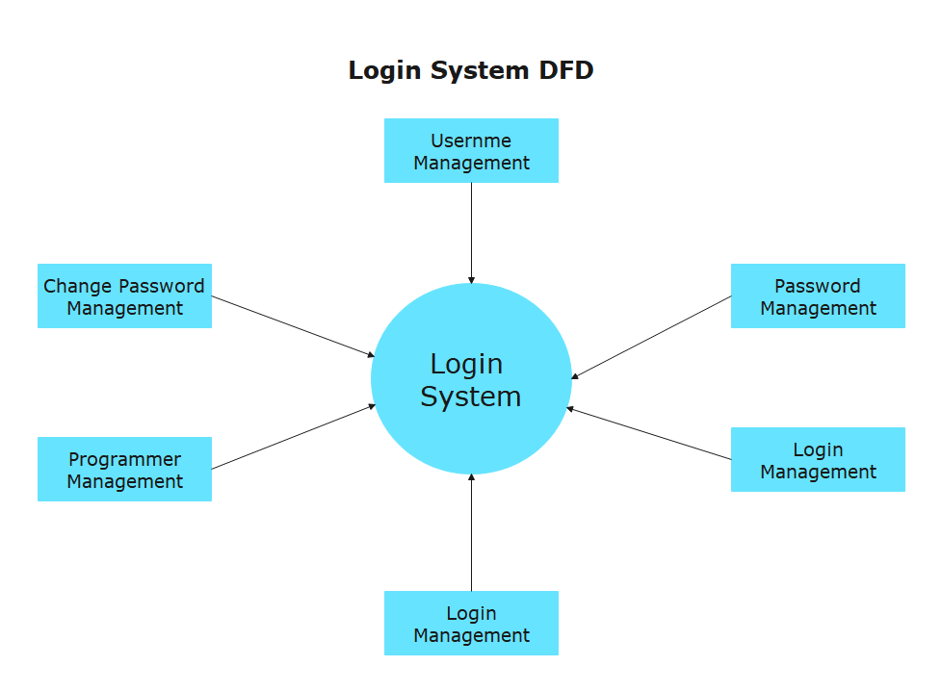

A typical Software Development Life Cycle consists of the following stages:

Page8

#### Stage 1: Planning and Requirement Analysis

Requirement analysis is the most important and fundamental stage in SDLC. It is performed by the senior members of the team with inputs from the customer, the sales department, market surveys and domain experts in the industry. This information is then used to plan the basic project approach and to conduct product feasibility study in the economical, operational and technical areas. Planning for the quality assurance requirements and identification of the risks associated with the project is also done in the planning stage. The outcome of the technical feasibility study is to define the various technical approaches that can be followed to implement the project successfully with minimum risks.

#### Stage 2: Defining Requirements

Once the requirement analysis is done the next step is to clearly define and document the product requirements and get them approved from the customer or the market analysts. This is done through an SRS (Software Requirement Specification) document which consists of all the product requirements to be designed and developed during the project life cycle.

#### Stage 3: Designing the Product Architecture

SRS is the reference for product architects to come out with the best architecture for the product to be developed. Based on the requirements specified in SRS, usually more than one design approach for the product architecture is proposed and documented in a DDS - Design Document Specification. This DDS is reviewed by all the important stakeholders and based on various parameters as risk assessment, product robustness, design modularity, budget and time constraints, the best design approach is selected for the product. A design approach clearly defines all the architectural modules of the product along with its communication and data flow representation with the external and third party modules (if any). The internal design of all the modules of the proposed architecture should be clearly defined with the minutest of the details in DDS.

Stage 4: Building or Developing the Product

Page9

In this stage of SDLC the actual development starts and the product is built. The programming code is generated as per DDS during this stage. If the design is performed in a detailed and organized manner, code generation can be accomplished without much hassle. Developers must follow the coding guidelines defined by their organization and programming tools like compilers, interpreters, debuggers, etc. are used to generate the code. Different high level programming languages such as C, C++, Pascal, Java and PHP are used for coding. The programming language is chosen with respect to the type of software being developed.

#### Stage 5: Testing the Product

This stage is usually a subset of all the stages as in the modern SDLC models, the testing activities are mostly involved in all the stages of SDLC. However, this stage refers to the testing only stage of the product where product defects are reported, tracked, fixed and retested, until the product reaches the quality standards defined in the SRS.

#### Stage 6: Deployment in the Market and Maintenance

Once the product is tested and ready to be deployed it is released formally in the appropriate market. Sometimes product deployment happens in stages as per the business strategy of that organization. The product may first be released in a limited segment and tested in the real business environment (UAT- User acceptance testing). Then based on the feedback, the product may be released as it is or with suggested enhancements in the targeting market segment. After the product is released in the market, its maintenance is done for the existing customer base.

**PROGRAMMING LANGUAGE**

* Python Programming language

**What is Python?**

Python is a popular programming language. It was created in 1991 by Guido van Rossum.

It is used for:

* web development (server-side),
* software development,
* mathematics,
* System scripting.

**What can Python do?**

* Python can be used on a server to create web applications.
* Python can be used alongside software to create workflows.
* Python can connect to database systems. It can also read and modify files.
* Python can be used to handle big data and perform complex mathematics.
* Python can be used for rapid prototyping, or for production-ready software development.

**Why Python?**

* Python works on different platforms (Windows, Mac, Linux, Raspberry Pi, etc).
* Python has a simple syntax similar to the English language.
* Python has syntax that allows developers to write programs with fewer lines than some other programming languages.
* Python runs on an interpreter system, meaning that code can be executed as soon as it is written. This means that prototyping can be very quick.
* Python can be treated in a procedural way, an object-orientated way or a functional way.

One area where Python shines is web development. Python offers many frameworks from which to choose from including bottle.py, Flask, CherryPy, Pyramid, Django and web2py. These frameworks have been used to power some of the world’s most popular sites such as Spotify, Mozilla, Reddit, the Washington Post and Yelp.

* Testing, mocking and Test Driven Development
* Integrating back-end code with front-end libraries and frameworks
* How to deploy your Python Web Application
* Containerizing web applications
* Designing and interacting with APIs
* Social Authentication
* Improving your application’s performance through caching

### Advantages of developing web applications in Python

* **Easy to learn:** Python is the most popular language for first-time learners for a reason. The language relies on common expressions and whitespace, which allows you to write significantly less code compared to some other languages like Java or C++. Not only that, but it has a lower barrier of entry because it’s comparatively more similar to your everyday language so you can easily understand the code.
* **Rich ecosystem and libraries:** Python offers a vast range of library tools and packages, which allows you to access much pre-written code, streamlining your application development time. For example, you have access to Numpy and Pandas for mathematical analysis, Pygal for charting, and SLQALchemy for composable queries. Python also offers amazing web frameworks like Django and Flask, which we’ll dive into later in the article.
* **Fast prototyping:** Because Python takes significantly less time to build your projects compared to other programming languages, your ideas come to life a lot faster, allowing you to gain feedback and iterate quickly. This quick development time makes Python especially great for startups who can hit the market sooner to gain a competitive edge.
* **Wide-spread popularity:** Python is one of the most popular languages in the world, with communities from all over the world. Because of how popular the language is, Python is continuously updated with new features and libraries, while also providing excellent documentation and community support. Especially for new developers, Python provides extensive support and framework for one to begin their developer journey.

**Django** is a Python web framework that offers an open-source, high-level framework that “encourages rapid development and clean, pragmatic design.” It’s fast, secure, and scalable. Django offers strong community support and detailed documentation.

Django is incredibly flexible in which you can work with MVPs to larger companies. For some perspective, some of the largest companies that use Django are Instagram, Dropbox, Pinterest, and Spotify.

**Python Features**

Python provides lots of features that are listed below.

***1) Easy to Learn and Use***

Python is easy to learn and use. It is developer-friendly and high level programming language.

***2) Expressive Language***

Python language is more expressive means that it is more understandable and readable.

***3) Interpreted Language***

Python is an interpreted language i.e. interpreter executes the code line by line at a time. This makes debugging easy and thus suitable for beginners.

***4) Cross-platform Language***

Python can run equally on different platforms such as Windows, Linux, Unix and Macintosh etc. So, we can say that Python is a portable language.

***5) Free and Open Source***

Python language is freely available at [offical web address](https://www.python.org/). The source-code is also available. Therefore it is open source.

***6) Object-Oriented Language***

Python supports object oriented language and concepts of classes and objects come into existence.

***7) Extensible***

It implies that other languages such as C/C++ can be used to compile the code and thus it can be used further in our python code.

***8) Large Standard Library***

Python has a large and broad library and prvides rich set of module and functions for rapid application development.

***9) GUI Programming Support***

Graphical user interfaces can be developed using Python.

***10) Integrated***

It can be easily integrated with languages like C, C++, JAVA etc.

**ABOUT TRAINING:**

* **HTML**
* **CSS**
* **JAVASCRIPT**
* **JQUERY**
* **MYSQL**
* **BOOTSTARP**
* **PYTHON**

**HARDWARE AND SOFTWARE REQUIREMENTS:**

* **HARDWARE REQUIREMENTS:**
* Pentium-IV (Processor).
* 256 MB Ram
* 512 KB Cache Memory
* Hard disk 10 GB
* Microsoft Compatible 101 or more Key Board
* **SOFTWARE REQUIREMENTS:**
* **Operating System :** Windows
* **Programming language:** PYTHON
* **Front-End:** HTML,CSS, J-query, Java script ,Django
* **Back-End: SQL**LITE
* **Web Server:** PYTHON Server 3.6

**PROJECT DESCRIPTION**

Paying guest accommodation

Since the house rental soars have been increasing day by day, it is becoming the big issue for the poor or middle class students to get a house on rent. Especially, house for rent is good for the big families, or small families (couples and a kid). But for students, it is not at all a good idea to stay in house. Because, students will not get enough time to study, and it becomes difficult for them to clean the house, clean bathrooms and toilets, etc. Hence, being a student, it’s really a better idea to go with Paying Guest accommodation. If you are looking for houses in the city of Mumbai, just drop your idea, as cost of the house rent seems to be high.

Why to Choose Paying Guest Accommodation?

There are several reasons to choose Paying Guest accommodations. One of the best reasons is that, you will be safe from terrorists, especially if you’re a girl. Secondly, you can save lots of time for your studies, as food will be provided in the PG for at least 2 to 3 times. So there is absolutely no need to worry at all. You will get ready bed, clean bed sheets, and blankets, etc. You’ll get good support from the PG owners or your PG mates if you get lost somewhere, your Tiffin box will be filled by the cook, and you can taste different sorts of food. Moreover, PG becomes helpful for you to mingle with different types of people, know their lifestyle, and learn their lifestyle. Your PG mates become the best companion for you, if you want to move outside. You can simply enjoy a lot with them. However, you need to find the best PG in Mumbai, as not all but only few PGs are great. Which Paying Guest Accommodation is better? There are many Paying Guest accommodations in Mumbai, out of which you can choose Andhra pg in Mumbai. As Andhra people are good at cooking, you’ll be able to get.

excellent food for at least twice or thrice a day for about 6 days a week. This will assist you to stay with comfort as you will get homely food. You need to search for the standard PG with the nearest location first – it should be near to your college or institution. Also, it must be near to the hotels or street food, shopping centres, and so on. You must also be able to find auto-rickshaws, buses, taxis, etc., nearby. Besides this, banks and ATMs are a must; So that, you can withdraw amount whenever required. Do not hurry in finding the pgs, just take your own time and find out the best Andhra PG in Mumbai. It will help you to stay in home away from home. But you need to enquire about the PG owners, regarding all the facilities provided in the PGs

There is no restriction for staying – either boy or a girl can stay in PG. Hence, there are separate PGs available for boys and girls. Even there are PGs which accommodates both boys and girls. It depends upon the individuals to choose the type of PG accommodation that is required.

**MODULES:**

1. **Login Module:**

Tenants can enter into the website by logging into the website. It contains two modules for login. For login, registration is done by the tenants and login id and password are provided to the user.

1. **Add details :**

User can add details by filling into registration form. User can upload the image.

1. **Choose problem:**

User can choose problem according to their system and can find solution.

1. **Updated account information:**

User can update or change the user account details like as change the user name, change the password, change the email address.

1. **Delete User:**

We can delete the user detail or delete the user by going in to the registration table.

**Scope of the Website**

* **Time saving:** PG ACCOMODATION is a time saving site because nobody needs to go door by door to find their shelter. we provide them a short period result of their search and tenants can give valuable feedback for better next time.
* **High Interactivity:** Easy steps to review, providing cell numbers, e-mail and feedback form for tenants. It is highly eye catching.

**ScreenShots**

**Home Page**

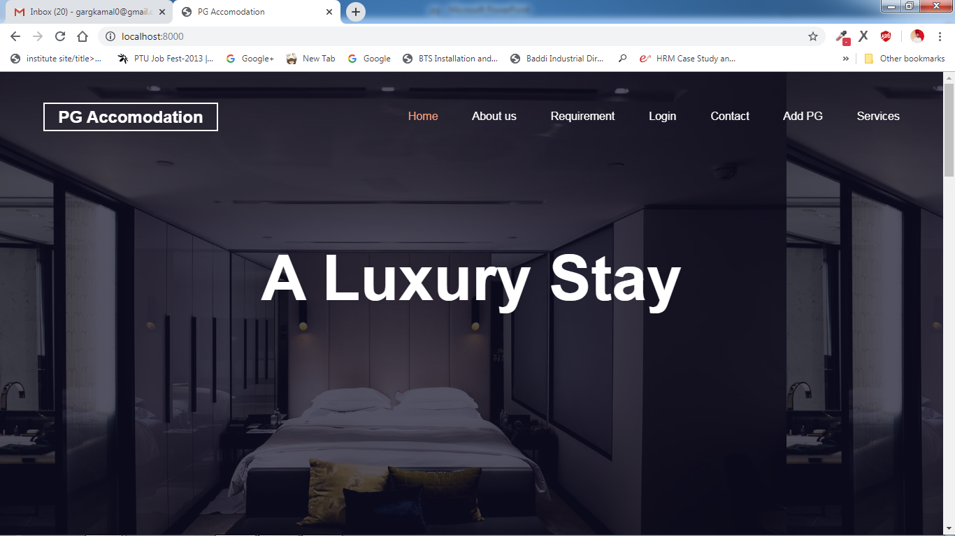

**About Us**

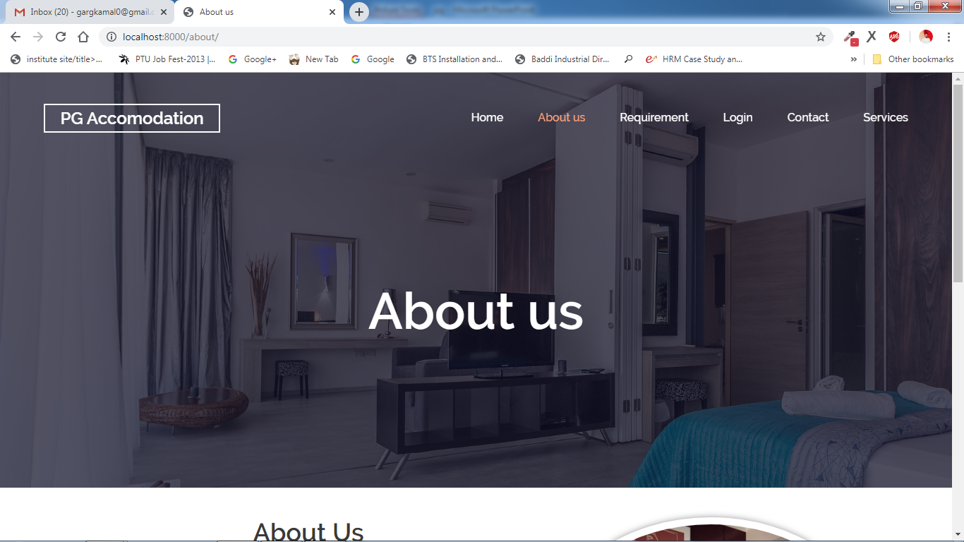

**Company Login Page**

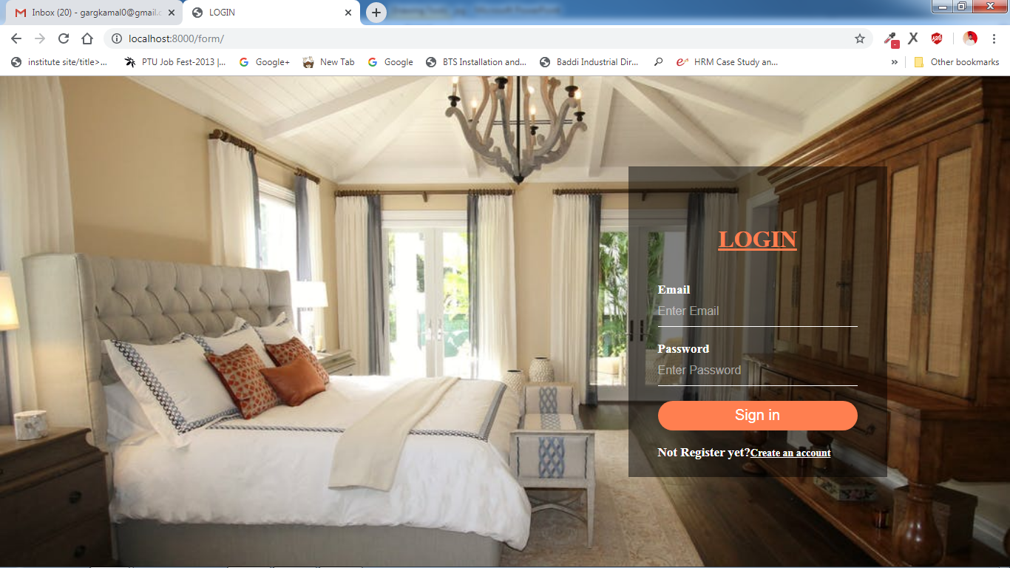

**Contact Page**

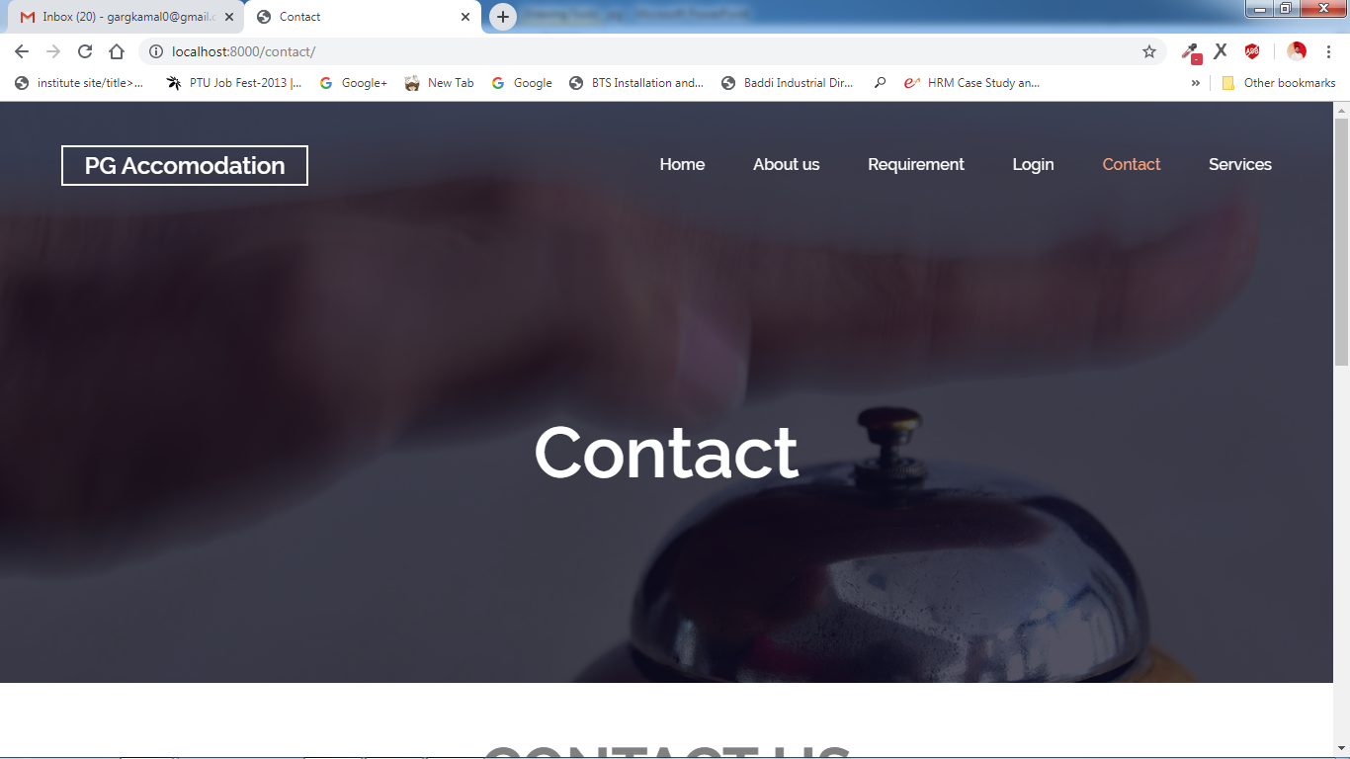

**Our Services**

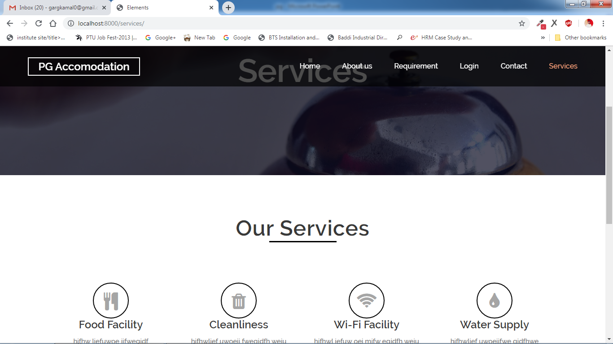

**Login Page**

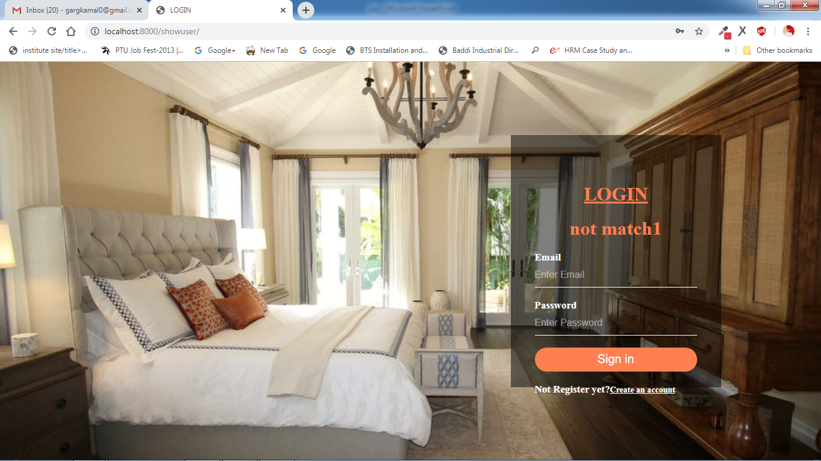

**REFERENCE**

* [www.w HYPERLINK "http://www.w3schools.com/" HYPERLINK "http://www.w3schools.com/" HYPERLINK "http://www.w3schools.com/"3 HYPERLINK "http://www.w3schools.com/" HYPERLINK HYPERLINK "http://www.w3schools.com/""http://www.w3schools.com/" HYPERLINK "http://www.w3schools.com/"schools.com](http://www.w3schools.com/)
* [www.phpbuddy.com](http://www.phpbuddy.com/)
* [www.mysql.com](http://www.mysql.com/)
* [www.phpeasystep.com](http://www.phpeasystep.com/)
* [www.infoq.com](http://www.infoq.com/)